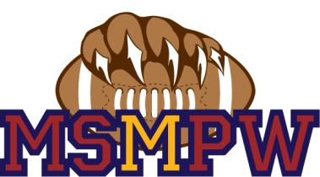
February 22, 2018 MSMPW Board Meeting
Open Meeting: 1820
Vote to adopt last month’s meeting minutes: 7 Yea 0 Nay
Attendees: Roll Call: Matt Spencer, Tosh Swain, Blake Jordan, Marianna Boyd, Terra Carroll, Mike Carroll, Brett Startin, Brandon G.
Visitors: Bill Boyd
Agenda
Officer reports:
President report: Field allocation discussed, New website(Blue Sombrero) Registration opens March 15th, this website is more cost efficient, early bird discount, multichild discount, new domain@godaddy. League business: New President: DJ Smith, all bilaws are being reviewed, Spokane Possible hosting regional playoffs.
Vice President report: No Report – discussed photographer
Treasurer report: $8700.00 – go daddy, storage, and honey pots going out
Secretary report: No Report
Football Commissioner report: No Report
Cheer Commissioner report: Discussed tumbling mats, approval pending final quote
Football Coaching Director report: Need coaches!!
Cheer Coaching Director report: No Report
Scholastics Director report: No Report
Area Coordinator report: Not Present
Development and Fundraising report: Working on donations-fundraisers- car washes (4thand18th) possible businesses to look into: Avista, Fred Meyers, Rosauers, Deleon Foods, Big 5, **Push Corporate Sponsorship.
Scholarships Coordinator report: Not present
Equipment Manager report: Not present
Web/Media Manager report: Not present

New Business:
Discussion of registration rates for next year: Player fee increase for INPWL (i.e. league fees).
Discussion and scheduling of Fundraising events for 2018. Ideas from board members on how to improve on fundraising activities. Must schedule fundraising events such as car wash’s in February.
Schedule coaches meeting for returning and new coaches. Brandon and Brett to contact coaches and set a meeting time/date.
Open Board Positions: Scholastics Director and Area Coordinator.
Corporate fundraising campaign to start 1/1/2018. All board members to participate in garnering corporate support. President will email all board members corporate sponsorship letter.
Reoccurring business- Please contact Terra Carroll with any persons to speak with regarding corporate sponsorships.
Open Discussion:
Vote for Non Comp. (TM,MM) raised to $220 : Motion(brett) Second(Blake)
8 Yay and o Nay

Dual Jerseys – sublimated
-Open Board positions
-Team apparel

Adjourn Meeting: 1958

